STORE SALES PREDICTION USING MACHINE LEARNING AND DEEP LEARNING

From Feature Engineering and Ensemble Learning to LSTM-Based Time-Series Forecasting
Project Type: Machine Learning & Deep Learning
Primary Technologies: Python, Pandas, NumPy, Scikit-learn, TensorFlow/Keras, Matplotlib, Seaborn, MLflow, Streamlit
Models: Random Forest, Gradient Boosting, LSTM
Deployment: Streamlit

1. Executive Summary
Accurate sales forecasting is an important component of retail decision-making. Reliable predictions can help organizations improve inventory planning, understand customer demand, optimize promotions, and make better operational decisions.
This project develops an end-to-end Store Sales Prediction system using both traditional Machine Learning and Deep Learning techniques.
The project begins with cleaned store-level data and performs feature engineering around:
- Store information
- Date and calendar information
- Promotions
- Holidays
- School holidays
- Competition
- Customer information
- Seasonal and temporal patterns
Two ensemble machine-learning models were developed and evaluated:
- Random Forest Regressor
- Gradient Boosting Regressor
The project was then extended into Deep Learning using an LSTM (Long Short-Term Memory) neural network to investigate whether temporal dependencies in historical sales could improve forecasting.
The best-performing traditional model was Random Forest, achieving:
Model | MAE | RMSE | R²
Random Forest | 353.60 | 574.03 | 0.9779
Gradient Boosting | 603.92 | 897.64 | 0.9460
LSTM | 1,725,982.88 | 2,583,624.38 | 0.3642
Although the LSTM did not outperform the traditional models in the submitted implementation, the deep-learning experiment provides an important insight: Deep Learning performance depends heavily on how the forecasting problem is formulated, the sequence structure, and the information supplied to the network.
The project also includes MLflow experiment tracking, model serialization using pickle/joblib, and preparation of a Streamlit application for prediction.

2. Business Problem
Retail organizations need accurate estimates of future sales to make operational and financial decisions.
Poor sales forecasting can result in:
- Overstocking
- Understocking
- Increased inventory costs
- Missed sales opportunities
- Inefficient workforce planning
- Poor promotion planning
- Difficulty managing seasonal demand
The objective of this project is therefore to develop a predictive model capable of estimating store sales using historical and operational information.
The project also investigates whether a recurrent neural network, specifically an LSTM, can learn temporal dependencies from historical sales data.

3. Project Objectives
The main objectives of the project are:
- Load and analyze cleaned store-sales data.
- Perform feature engineering to extract useful business and temporal features.
- Build a reusable preprocessing pipeline.
- Develop traditional Machine Learning models.
- Compare Random Forest and Gradient Boosting performance.
- Analyze feature importance.
- Investigate the time-series characteristics of sales.
- Develop an LSTM Deep Learning model.
- Evaluate the LSTM using MAE, RMSE and R².
- Compare Deep Learning with traditional Machine Learning.
- Track experiments using MLflow.
- Serialize trained models for deployment.
- Build a Streamlit prediction application.

4. Dataset Overview
The cleaned dataset used in the project contains:
- Training dataset: 1,017,209 rows × 29 columns
- Test dataset: 41,088 rows × 23 columns
The data contains information related to stores, dates, promotions, holidays, competition and customers.

Major feature categories
Feature Category | Examples
Store | Store, StoreType, Assortment
Calendar | Year, Month, Day, Quarter, WeekOfYear
Day information | DayOfWeek, IsWeekend
Promotion | Promo, Promo2, PromoInterval
Holiday | StateHoliday, SchoolHoliday
Competition | CompetitionDistance, CompetitionAgeMonths
Temporal | MonthPeriod, CompetitionPeriod
Customers | Customers
Derived features | DaysToHoliday, DaysAfterHoliday

Screenshot – Dataset
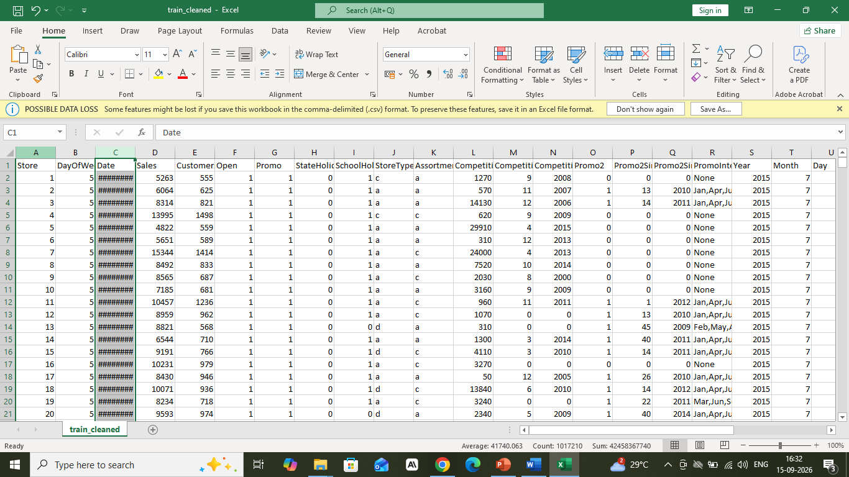Figure 1: Sample of the cleaned training dataset.

5. Data Preprocessing
The project uses a structured preprocessing pipeline to make the data suitable for Machine Learning.

5.1 Date Processing
The date information is converted into a proper datetime representation.
The project extracts multiple temporal features including:
- Year
- Month
- Day
- Quarter
- Week of Year
- Day of Week
- Weekend indicator
- Month start indicator
- Month end indicator
These features help the models capture seasonal and calendar-based sales behaviour.

6. Feature Engineering
Feature engineering is an important part of the project because raw data alone may not provide enough information for the models to identify business patterns.

6.1 Promotion Features
Promotion-related variables include:
- Promo
- Promo2
- PromoInterval
Promotions can significantly influence store traffic and sales.

6.2 Holiday Features
Holiday-related features include:
- StateHoliday
- SchoolHoliday
- IsStateHoliday
- IsSchoolHoliday
- IsHoliday
- DaysToHoliday
- DaysAfterHoliday
These features help capture changes in customer purchasing behaviour around holidays.

6.3 Competition Features
Competition information is transformed into useful variables such as:
- CompetitionDistance
- CompetitionDistanceBand
- CompetitionOpenSinceMonth
- CompetitionOpenSinceYear
- CompetitionAgeMonths
- MonthsSinceCompetition
- CompetitionPeriod
These variables allow the model to understand how the competitive environment around a store can influence sales.

6.4 Store-Level Features
The model also uses store-specific information such as:
- Store
- StoreType
- Assortment
These features allow the model to learn differences between stores.

7. Preprocessing Pipeline
A Scikit-learn preprocessing pipeline was created to ensure consistent transformation of training and prediction data.

Numerical features
Numerical variables are processed using:
Median Imputation → StandardScaler

Categorical features
Categorical variables are processed using:
Most-Frequent Imputation → OneHotEncoder
The OneHotEncoder uses:
handle_unknown="ignore"
This is particularly useful during deployment because the application may receive categorical values that were not present in the training dataset.
The preprocessing and model are combined into a single Scikit-learn Pipeline.

Why this approach is important
A single pipeline reduces the risk of training-serving inconsistencies because the same transformations are automatically applied during prediction.

8. Machine Learning Modelling
Two ensemble regression algorithms were implemented.

8.1 Random Forest Regressor
The Random Forest model was configured with:
- Number of estimators: 200
- Maximum depth: 20
- Random state: 42
Random Forest combines multiple decision trees and averages their predictions.
It is particularly effective for datasets containing:
- Non-linear relationships
- Mixed feature types
- Complex interactions
- High-dimensional feature spaces

9. Gradient Boosting Regressor
The second model was Gradient Boosting.
Configuration:
- Estimators: 200
- Learning rate: 0.05
- Maximum depth: 5
- Random state: 42
Gradient Boosting builds trees sequentially, with each new tree attempting to improve the errors made by the previous trees.

10. Model Evaluation
Three evaluation metrics were used.

Mean Absolute Error – MAE
MAE represents the average absolute difference between actual and predicted values.
Lower MAE indicates better prediction accuracy.
MAE was selected as an important business metric because it is directly interpretable in the original sales units.

Root Mean Squared Error – RMSE
RMSE gives greater importance to large prediction errors.
This is useful in sales forecasting because very large errors can have significant business consequences.

R² Score
R² measures the proportion of variance explained by the model.
A value closer to 1 indicates stronger explanatory performance.

11. Machine Learning Results
The Random Forest model produced:
MAE = 353.60
RMSE = 574.03
R² = 0.9779
Gradient Boosting produced:
MAE = 603.92
RMSE = 897.64
R² = 0.9460
Therefore, Random Forest performed better on the submitted validation set.

Model Comparison
Metric | Random Forest | Gradient Boosting
MAE | 353.60 | 603.92
RMSE | 574.03 | 897.64
R² | 0.9779 | 0.9460

Screenshot – Model Comparison
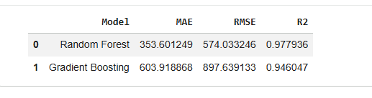

12. Actual vs Predicted Analysis
The project also compares actual sales with predicted sales.
The actual-versus-predicted visualization helps determine whether the model predictions follow the real sales distribution.
A strong concentration of predictions around the ideal prediction line indicates that the model is capturing the underlying relationship between the input features and sales.

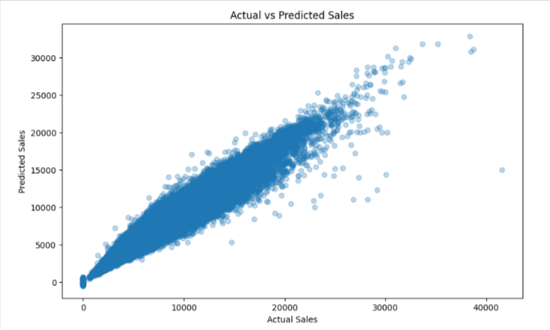
Figure 2: Actual vs predicted sales.

13. Prediction Error Analysis
Prediction errors were also visualized to understand the distribution of forecasting errors.
Error analysis is important because two models can have similar average performance while behaving very differently for extreme cases.

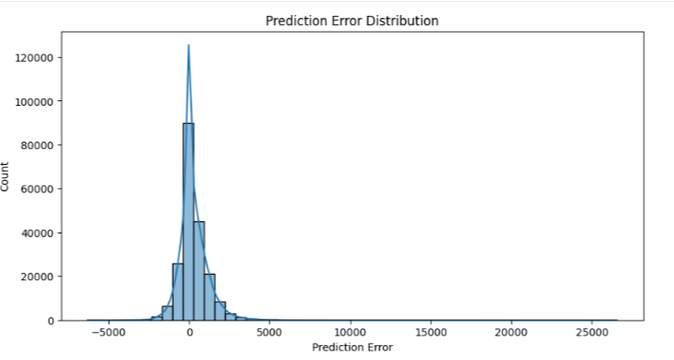
Figure 3: Distribution of prediction errors.

14. Feature Importance
Feature importance was analyzed to understand which variables contribute most to the model’s predictions.
The feature-importance analysis provides business interpretability and helps identify variables that have strong relationships with sales.
The analysis highlights the importance of customer-related, store-related, promotion, competition and temporal variables.
Feature importance can be useful for business stakeholders because it provides an indication of which factors should receive more attention when planning sales and operational strategies.

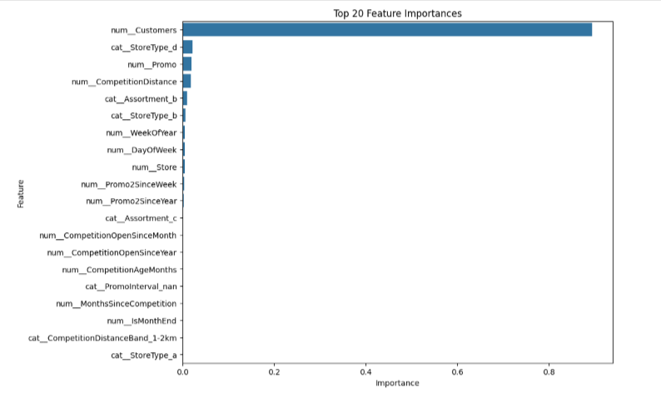Figure 4: Top 20 feature importances.

15. Deep Learning Modelling

LSTM-Based Sales Forecasting
One of the most important components of this project is the implementation of a Long Short-Term Memory (LSTM) neural network.
Traditional tree-based models treat the observations primarily as tabular records.
However, sales data also has a temporal dimension.
Sales today may depend on:
- Previous days’ sales
- Weekly patterns
- Seasonal behaviour
- Promotional periods
- Holiday effects
- Recent demand trends
This makes recurrent neural networks an interesting approach for sales forecasting.

16. Why LSTM?
LSTM is a type of Recurrent Neural Network designed to learn dependencies across sequences.
A conventional neural network does not naturally maintain information about previous observations.
LSTM introduces memory mechanisms that allow the network to learn information from previous time steps.
Conceptually, the forecasting process is:
Historical Sales → Sequence Construction → LSTM → Next Sales Prediction
For example:
Day 1
Day 2
Day 3
...
Day 14
↓
LSTM Network
↓
Prediction for Day 15
This project uses a 14-day historical window.
Therefore, the model receives the previous 14 observations and attempts to predict the next observation.

17. Time-Series Preparation
Before developing the LSTM, the sales data was transformed into a daily time series.
The data was ordered chronologically.
An important step was to investigate whether the time series contains statistical properties such as stationarity and temporal autocorrelation.
The project therefore applies:
- Augmented Dickey-Fuller test
- First differencing
- Autocorrelation Function (ACF)
- Partial Autocorrelation Function (PACF)

18. Augmented Dickey-Fuller Test
The Augmented Dickey-Fuller test was used to investigate stationarity.
For the original daily sales series, the reported p-value was:
6.4367 × 10⁻⁵
The result indicates evidence against the null hypothesis of a unit root at conventional significance levels.
After first differencing, the reported p-value became:
3.7500 × 10⁻²⁶
This demonstrates a very strong statistical signal after differencing.
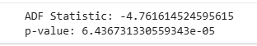Figure 5: Time-series stationarity analysis.

19. ACF and PACF Analysis
The project also analyzes the ACF and PACF of the differenced series.

ACF – Autocorrelation Function
ACF measures the relationship between a time series and its previous observations at different lags.
It helps identify how strongly historical observations are related to future observations.

PACF – Partial Autocorrelation Function
PACF measures the relationship between observations at different lags after accounting for intermediate lags.
Together, ACF and PACF provide useful information when determining appropriate sequence structures for time-series modelling.
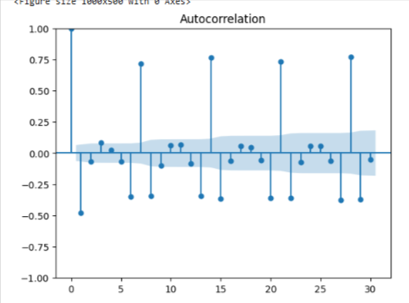
Figure 6: Autocorrelation Function.
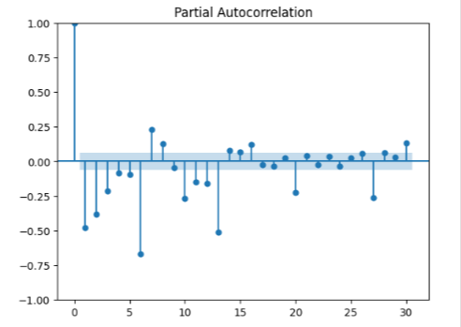
Figure 7: Partial Autocorrelation Function.

20. LSTM Sequence Construction
The project converts the daily sales series into supervised learning sequences.
A sliding-window approach is used.
The selected window size is:
14 days
For every training example:
Input:
Sales[t-14], Sales[t-13], ..., Sales[t-1]
Target:
Sales[t]
This produces a three-dimensional input structure:
(samples, timesteps, features)
The final feature dimension is:
1
Therefore, the LSTM input represents:
14 time steps × 1 feature

21. Data Scaling for LSTM
The sales values are scaled using:
MinMaxScaler
with the range:
(-1, 1)
Scaling is especially important for neural networks because large differences in numerical magnitude can make optimization more difficult.
The scaler is fitted on the training portion and then applied to the test portion.
After prediction, the values are transformed back into the original sales scale using inverse transformation.

22. LSTM Architecture
The project implements a two-layer LSTM architecture.

Architecture
Input
14 time steps × 1 feature
│
▼
LSTM Layer
64 units
return_sequences = True
│
▼
Dropout
20%
│
▼
LSTM Layer
32 units
return_sequences = False
│
▼
Dropout
20%
│
▼
Dense Layer
1 output
│
▼
Predicted Sales
This architecture allows the network to progressively learn temporal representations.

23. First LSTM Layer
The first LSTM layer contains:
64 units
and uses:
return_sequences=True
This configuration is required because the output sequence from the first LSTM is passed into the second LSTM layer.
The first layer therefore acts as an initial temporal feature extractor.

24. Dropout Regularization
A dropout rate of:
20%
is applied after each LSTM layer.
Dropout randomly deactivates a portion of neurons during training.
The purpose is to reduce overfitting and encourage the model to learn more robust representations.

25. Second LSTM Layer
The second LSTM layer contains:
32 units
and uses:
return_sequences=False
This means the layer produces a final representation that is passed to the Dense output layer.
The reduction from 64 to 32 units provides a compact representation of the temporal information learned by the network.

26. Output Layer
The final layer is:
Dense(1)
The single neuron produces the predicted sales value.
Because the problem is a regression problem, there is no classification activation function such as Softmax or Sigmoid on the output.

27. LSTM Training Configuration
The LSTM was compiled using:
Optimizer: Adam
Loss Function: MAE
Training configuration:
- Epochs: 20
- Batch size: 32
- Validation split: 10%
The use of MAE aligns the neural-network training objective with the primary business evaluation metric.

28. LSTM Training Behaviour
The training history records both:
- Training MAE
- Validation MAE
The training loss generally decreases as the model learns.
However, the validation loss remains noticeably higher and fluctuates across epochs.
This behaviour suggests that the current LSTM configuration has limitations in generalizing the learned temporal patterns.
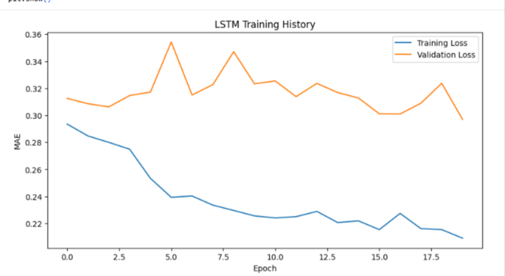
Figure 8: LSTM training and validation loss.

29. LSTM Prediction Process
After training, the LSTM generates predictions for the test sequences.
The prediction values are initially in the scaled range.
Therefore, the predictions are converted back to the original sales scale using:
Inverse MinMax Transformation
↓
Original Sales Units
The final predictions can then be compared directly with actual sales values.

30. LSTM Evaluation Results
The submitted LSTM model achieved:
MAE = 1,725,982.88
RMSE = 2,583,624.38
R² = 0.3642
These results are substantially weaker than the Random Forest and Gradient Boosting models.

Complete Model Comparison
Model | MAE | RMSE | R²
Random Forest | 353.60 | 574.03 | 0.9779
Gradient Boosting | 603.92 | 897.64 | 0.9460
LSTM | 1,725,982.88 | 2,583,624.38 | 0.3642

31. Why Did the LSTM Underperform?
The LSTM result should not simply be interpreted as “Deep Learning is worse.”
The more important conclusion is that the current LSTM problem formulation is different from the tabular Machine Learning problem.
The tree-based models use rich features including:
- Customers
- Store information
- Promotions
- Holidays
- Competition
- Calendar variables
- Engineered features
The LSTM experiment, however, uses a daily sales sequence and predicts the next value from the historical sequence.
Therefore, the two approaches do not have exactly the same information available.
This is an important modelling insight.

32. Key Deep Learning Improvement Opportunities
The current LSTM can be significantly improved in future iterations.

32.1 Multivariate LSTM
Instead of using only historical sales, the LSTM could receive multiple features at every time step.
For example:
Sales
Customers
Promo
SchoolHoliday
StateHoliday
CompetitionDistance
DayOfWeek
Month
StoreType
This would allow the neural network to learn relationships between sales and external business drivers.

32.2 Store-Specific LSTM
The current time-series approach aggregates sales by date.
A stronger approach would maintain separate sequences for each store.
For example:
Store 1
Day 1 → Day 2 → ... → Day 14 → Prediction
Store 2
Day 1 → Day 2 → ... → Day 14 → Prediction
This could preserve store-specific sales behaviour.

32.3 Longer Look-Back Window
The current model uses:
14 days
Future experiments could compare:
- 7 days
- 14 days
- 30 days
- 60 days
- 90 days
Longer windows may help the network learn weekly and monthly seasonal patterns.

32.4 Hyperparameter Tuning
The following parameters could be optimized:
- Number of LSTM layers
- Number of neurons
- Dropout rate
- Learning rate
- Batch size
- Sequence length
- Number of epochs
Automated hyperparameter tuning could further improve performance.

33. Alternative Deep Learning Models
The project could also be extended with:
- GRU
- Bidirectional LSTM
- CNN-LSTM
- Attention-based LSTM
- Transformer-based forecasting models
A GRU could be particularly useful as a lighter recurrent alternative to LSTM.
For more advanced forecasting, Transformer-based architectures could be investigated for learning long-range dependencies.

34. Machine Learning vs Deep Learning
One of the most important lessons from this project is that the most complex model is not necessarily the best model.
The results demonstrate:
Random Forest
R² = 0.9779
↓
Strongest submitted result
Gradient Boosting
R² = 0.9460
↓
Strong performance
LSTM
R² = 0.3642
↓
Requires improved sequence formulation
Traditional ensemble models can perform extremely well when the dataset contains rich structured features.
Deep Learning becomes more attractive when:
- Large amounts of sequential data are available
- Temporal relationships are important
- Multivariate sequences can be constructed
- The neural architecture matches the problem structure

35. MLflow Experiment Tracking
The project also includes MLflow for experiment tracking.
The experiment is named:
Rossmann_Sales_Prediction
The Gradient Boosting experiment records information such as:
- Model type
- Number of estimators
- Learning rate
- MAE
- RMSE
- R²
- Model artifact
This provides a foundation for reproducible Machine Learning experimentation.
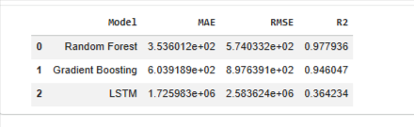Figure 9: MLflow experiment tracking.

36. Model Serialization
The trained models are serialized for deployment.
The project uses Python model serialization through pickle/joblib.
The deployment preparation includes:
sales_model_gb.pkl
customer_model_gb.pkl
The advantage of serialization is that the trained pipeline can be loaded later without retraining the model.

37. Customer Prediction Model
In addition to sales prediction, the deployment notebook creates a Gradient Boosting model for customer prediction.
The reported customer model results are:
- MAE: 0.32
- RMSE: 0.64
- R²: 1.00
The model is also serialized for use by the Streamlit application.

38. Streamlit Deployment
A Streamlit application was created with the title:
Store Sales & Customer Prediction
The application provides functionality to:
- Load the trained sales model.
- Load the trained customer model.
- Upload a CSV file.
- Display uploaded data.
- Generate sales predictions.
- Generate customer predictions.
- Display prediction results.
- Visualize predicted sales.
- Visualize predicted customers.

Application workflow
CSV Upload
↓
Data Validation
↓
Pre-trained Sales Model
↓
Predicted Sales
CSV Upload
↓
Data Validation
↓
Pre-trained Customer Model
↓
Predicted Customers

39. Deployed Application
The Streamlit application was successfully started during the deployment preparation process.
The notebook confirms that the Streamlit server started successfully.
For the final submission, a permanent deployment URL should be provided.
Live Application: https://germicide-said-squishy.ngrok-free.dev/

Dashboard Screenshot
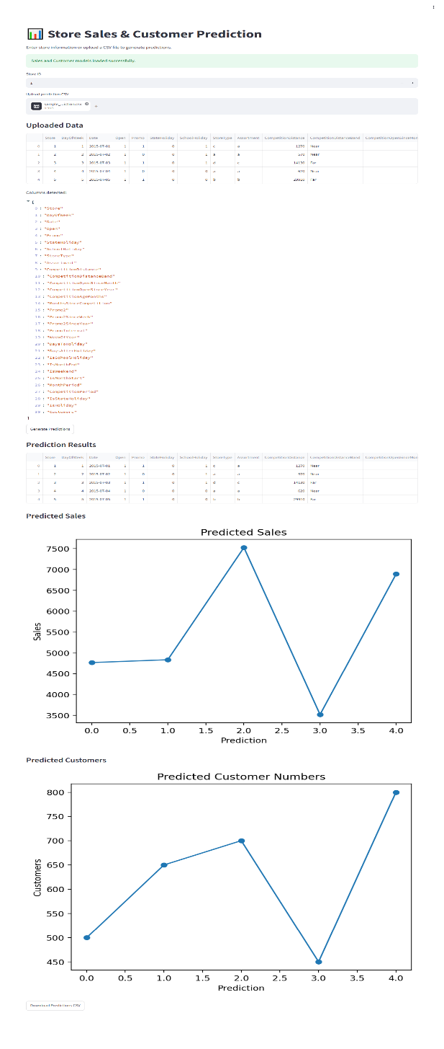
Figure 10: Store Sales & Customer Prediction dashboard.

40. GitHub Repository
The complete project should be maintained in a GitHub repository containing:
project/
│
├── pharma_store_prediction.ipynb
├── Deployment_Preparation.ipynb
├── app.py
├── requirements.txt
│
├── models/
│ ├── sales_model_gb.pkl
│ └── customer_model_gb.pkl
│
├── sample_data/
│ └── sample_store_prediction.csv
│
└── README.md
GitHub Repository:
https://github.com/Nupurkpatel63/rossmansales_pharmastore_timeseries
The repository should include the Jupyter notebook as requested in the submission criteria.

41. End-to-End Architecture
The complete solution can be represented as:
RAW / CLEANED DATA
│
▼
DATA PREPROCESSING
│
▼
FEATURE ENGINEERING
│
┌─────────┴─────────┐
│ │
▼ ▼
TABULAR ML PATH TIME-SERIES PATH
│ │
▼ ▼
Random Forest / Daily Sales Series
Gradient Boosting │
│ ▼
│ ADF / ACF / PACF
│ │
│ ▼
│ Sequence Creation
│ │
│ ▼
│ 14-Day Window
│ │
│ ▼
│ LSTM
│ │
└─────────┬──────────┘
▼
MODEL EVALUATION
│
▼
EXPERIMENT TRACKING
MLflow
│
▼
MODEL SERIALIZATION
│
▼
STREAMLIT
│
▼
PREDICTION DASHBOARD

43. Key Findings
The project produced several important findings.

Finding 1 – Random Forest was the strongest submitted model
Random Forest achieved an R² of:
0.9779
with MAE of:
353.60
This was the strongest validation performance among the submitted models.

Finding 2 – Gradient Boosting also performed strongly
Gradient Boosting achieved:
R² = 0.9460
This confirms that ensemble tree methods are highly effective for this structured dataset.

Finding 3 – Feature engineering is highly valuable
Calendar, promotion, holiday, competition and store-related variables provide valuable information to the models.

Finding 4 – Temporal dependency exists in sales
The ADF, ACF and PACF analyses demonstrate that the sales data contains meaningful time-series characteristics worth investigating.

Finding 5 – The current LSTM requires improvement
The LSTM achieved:
R² = 0.3642
which is significantly below the traditional ML models.
However, this does not mean LSTM is unsuitable for sales forecasting.
Instead, it highlights the importance of:
- Sequence design
- Feature selection
- Store-specific modelling
- Multivariate inputs
- Look-back window selection
- Hyperparameter tuning

Finding 6 – Deployment pipeline was successfully prepared
The project includes:
- Serialized sales model
- Serialized customer model
- Streamlit application
- CSV upload
- Prediction generation
- Prediction visualization

44. Future Enhancements
Several improvements can make the solution more production-ready.

Data Enhancements
- Add more historical data.
- Improve handling of missing values.
- Add weather information.
- Add regional economic indicators.
- Add product-level information.

Machine Learning Enhancements
- Hyperparameter optimization.
- XGBoost.
- LightGBM.
- CatBoost.
- Ensemble stacking.

Deep Learning Enhancements
- Multivariate LSTM.
- Store-specific LSTM.
- GRU.
- CNN-LSTM.
- Attention mechanisms.
- Transformer forecasting.
- Longer historical windows.
- Early stopping.
- Learning-rate scheduling.

MLOps Enhancements
- Model versioning.
- Automated CI/CD.
- Docker containerization.
- Cloud deployment.
- Model monitoring.
- Data drift detection.
- Automated retraining.

45. Conclusion
This project demonstrates an end-to-end Store Sales Prediction solution combining traditional Machine Learning, Deep Learning and deployment practices.
The Machine Learning experiments demonstrate that ensemble tree-based algorithms can be highly effective for structured retail data. Random Forest achieved the best submitted validation performance with an R² of 0.9779, while Gradient Boosting achieved an R² of 0.9460.
The Deep Learning component extends the project into time-series forecasting using an LSTM network. The LSTM uses a 14-day sequence window, two recurrent layers containing 64 and 32 units, dropout regularization, Adam optimization and MAE loss.
Although the current LSTM achieved an R² of 0.3642, the experiment provides an important technical insight. Deep Learning performance depends not simply on using a neural network, but on correctly representing the forecasting problem.
The current LSTM uses a relatively limited univariate sequence formulation compared with the rich feature set available to the traditional models. A future multivariate, store-specific LSTM could incorporate promotions, customers, holidays, competition and calendar features alongside historical sales.
The project also demonstrates practical MLOps concepts through MLflow experiment tracking, model serialization and Streamlit deployment preparation.
Overall, the project demonstrates the complete lifecycle:
Data → Feature Engineering → Machine Learning → Deep Learning → Evaluation → Experiment Tracking → Model Serialization → Deployment

46. Final Submission Links

GitHub Repository

https://github.com/Nupurkpatel63/rossmansales_pharmastore_timeseries

Jupyter Notebook

https://colab.research.google.com/drive/1rodmYvMx0v6GyXOoHLm-FUfrnjmK7Fdv
https://colab.research.google.com/drive/1yMn2ybSj4cJ_LzLrdaF3HiB2jpAIM637
https://colab.research.google.com/drive/11zx3-teGV19avJE169ZZfTqo9rGsXWS7

Deployed Application

https://germicide-said-squishy.ngrok-free.dev/

47. Project Summary
Component | Implementation
Data Processing | Pandas / NumPy
Feature Engineering | Calendar, Promotion, Holiday, Competition, Store
Preprocessing | Imputation + Scaling + One-Hot Encoding
ML Model 1 | Random Forest Regressor
ML Model 2 | Gradient Boosting Regressor
Deep Learning | 2-Layer LSTM
LSTM Window | 14 time steps
LSTM Units | 64 → 32
Regularization | Dropout 20%
Optimizer | Adam
Loss | MAE
Experiment Tracking | MLflow
Model Serialization | Pickle / Joblib
Application | Streamlit
Sales Best R² | 0.9779
LSTM R² | 0.3642

Final Statement
The key lesson from this project is that model complexity should be driven by the structure of the problem rather than by the assumption that Deep Learning will always produce better results.
The traditional ensemble models performed exceptionally well on the engineered tabular data, while the LSTM highlighted opportunities for further research into multivariate and store-specific time-series forecasting.
The project therefore provides both a strong predictive baseline and a clear roadmap for future Deep Learning improvements.

